Objective Questions

- Are there any tables with duplicate or missing null values? If so, how would you handle them?

Ans: Out of all the 7 tables none have null values or missing values.
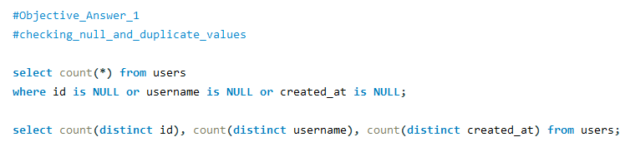
If so, following steps will be taken to handle missing null values or duplicate values-
- Delete the missing or null values.
- Fill the null columns of the tables with values like ‘NA’ or 0 or with average of values in case of a numerical field.

- What is the distribution of user activity levels (e.g., number of posts, likes, comments) across the user base?

Ans:

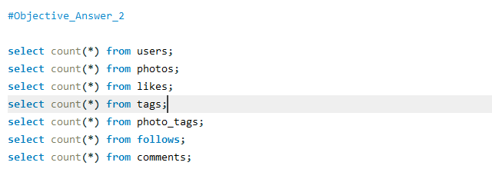

Visualization;

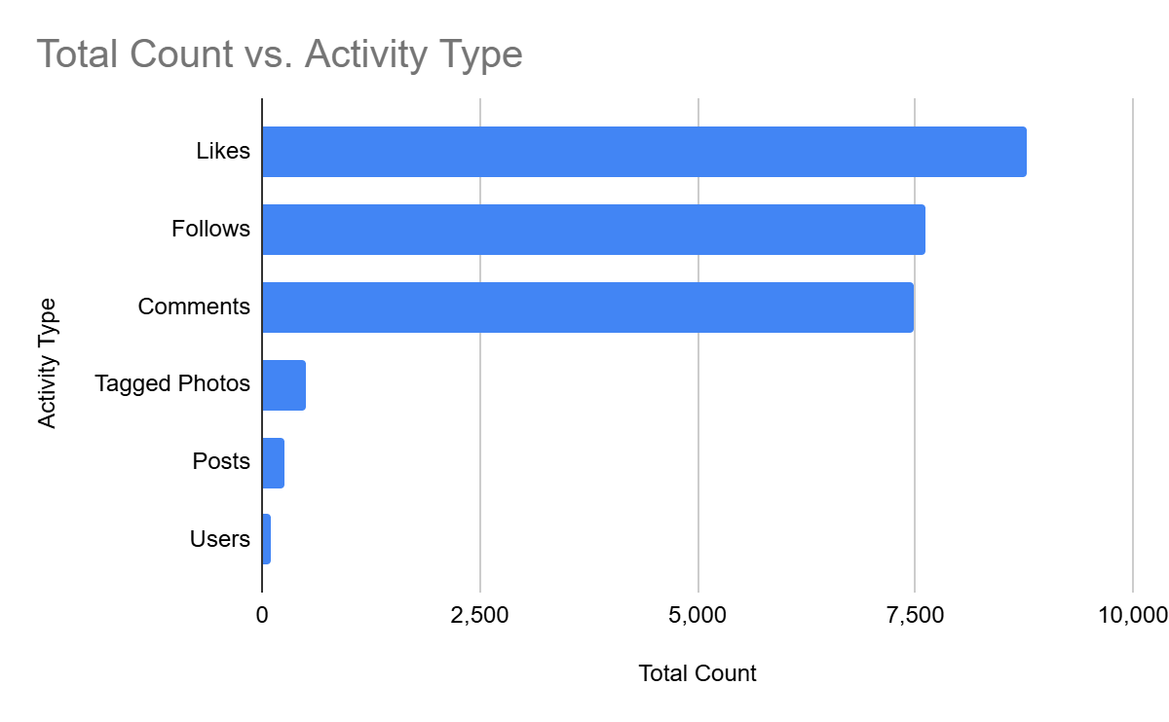
Visualization Insight: > As seen in the bar chart above, the platform exhibits a highly "consumptive" user behavior. The volume of engagement actions (Likes: 8,782 and Comments: 7,488) is astronomically higher than content creation actions (Posts: 257). This indicates that while only a few users create content, the vast majority actively consume and engage with it.

- Calculate the average number of tags per post (photo_tags and photos tables).

Ans: The average number of tags per post is 2.6368

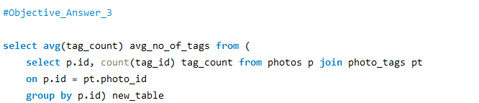

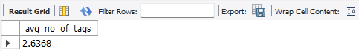

- Identify the top users with the highest engagement rates (likes, comments) on their posts and rank them.

Ans:
Engagement Rate = $\frac{Total Engagements (Total_likes+Total_comments)}{Number of Followers}$ X 100

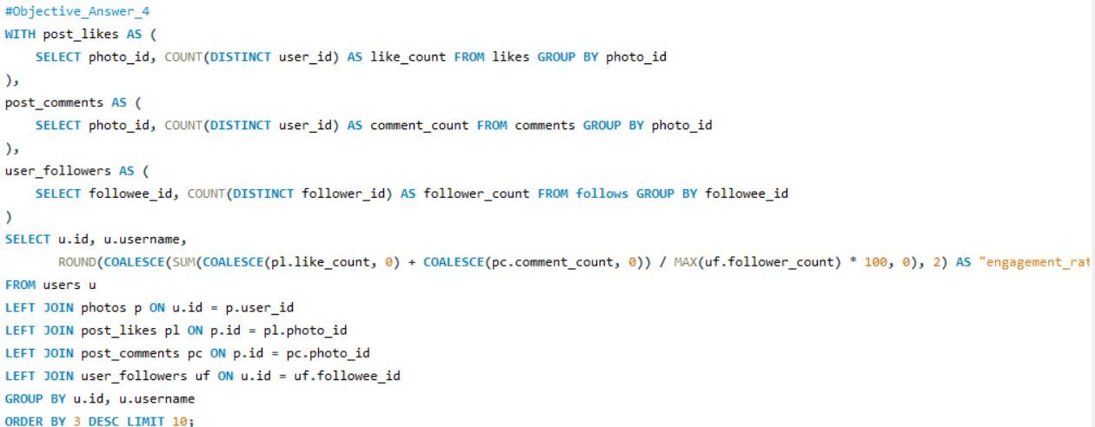Using this formula top 10 users with the highest engagement rates are identified.
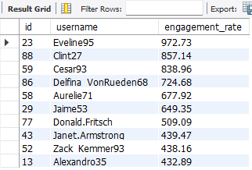

- Which users have the highest number of followers and followings?

Ans: Aurelie71, Bartholome.Bernhard, Cesar93 and 20 other users have the highest number of followers with a count of 77 followers.

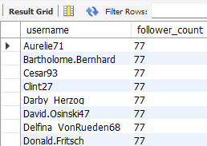
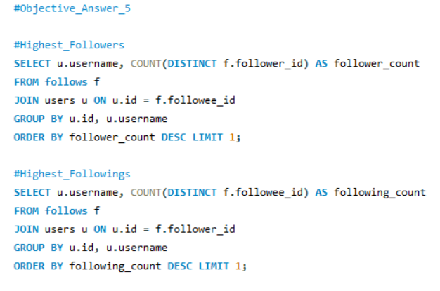

Adelle96, Aiyana_Hoeger, Alek_Watsica and 74 other users have the highest number of following with a following count of 99.

- Calculate the average engagement rate (likes, comments) per post for each user.

Ans: The average engagement rate per post for each user-

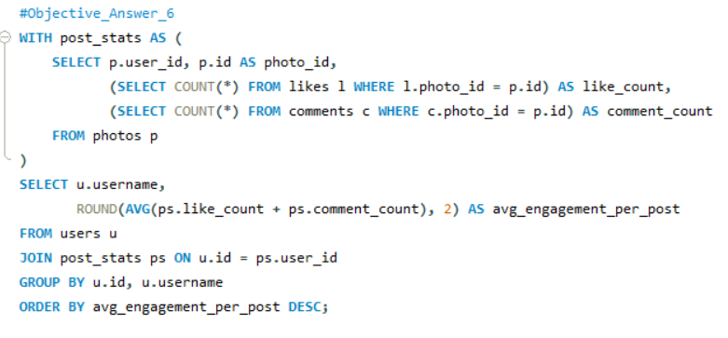

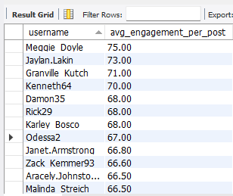

- Get the list of users who have never liked any post (users and likes tables)

Ans: Here is the list of users who have never liked any post -

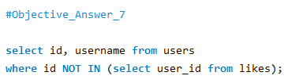

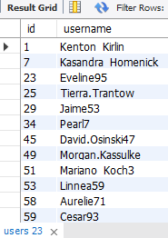

- How can you leverage user-generated content (posts, hashtags, photo tags) to create more personalized and engaging ad campaigns?

Ans: The data provided in the users, photos, follows, comments, likes, tags and photo_tags tables can be used to gain insights into user trends and interests. Hence, we can leverage user-generated content (posts, hashtags, photo tags) to create more personalized and engaging ad campaigns.

Reference -1:

Query:

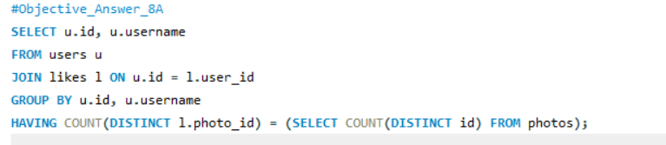

Output:
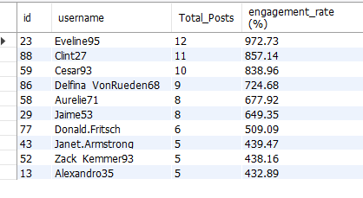
Visualization:
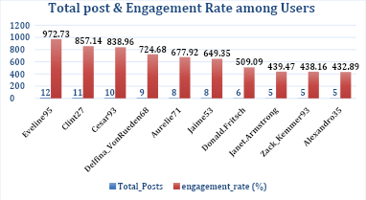

Reference-2:

Query:
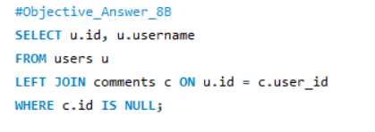
Output:

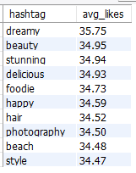

Visualization:
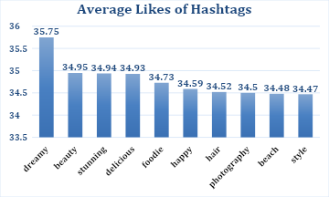

By utilizing the data from the above references, we can create hyper-targeted ad campaigns based on the following:

- User interests (derived from photos and tags)
- Engagement (likes and comments)
- Influence (followers and followees)
- User behaviour (encouraging non-engagers to participate)
- Personalized ad strategies (based on engagement rate)

- Are there any correlations between user activity levels and specific content types (e.g., photos, videos, reels)? How can this information guide content creation and curation strategies?

Ans:

Reference:

Query:
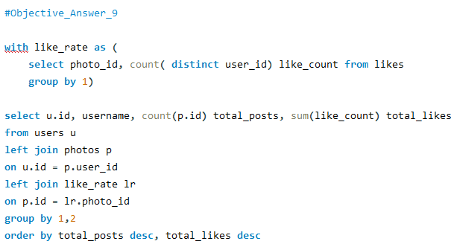

Output:
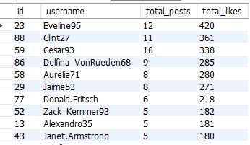

Visualization:
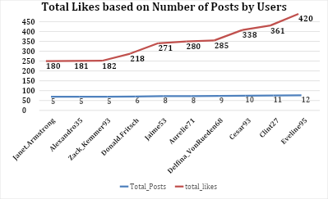

There is a correlation between user activity levels and specific content type (Photos). We can see, by the increase of Number of Posts, Total Likes are also increasing.

By analysing user activity levels and their interaction with different content types, we can gather valuable insights that help users:

- Prioritize High-Performing Content: Focus content creation efforts on the types that yield the highest engagement. For instance, if videos and reels are more effective, invest in high-quality video production.

- Optimize Posting Schedule: Align content type publication with peak engagement times identified through the analysis to maximize visibility and interaction.

- Tailored Content Strategies: Develop targeted content strategies based on user demographics. For instance, younger audiences might engage more with reels, while older demographics may prefer informative videos or images.

- Iterative Improvement: Continuously monitor engagement metrics after implementing new content strategies, using data to refine and optimize future content plans.
However, the current database is limited to photos and does not cover other post types. Hence, with the provided database, it would be difficult to gain actual insights into the correlation between user activity labels and specific content types.

- Calculate the total number of likes, comments, and photo tags for each user.

Ans: Total number of likes, comments, and photo tags for each user has been calculated here-
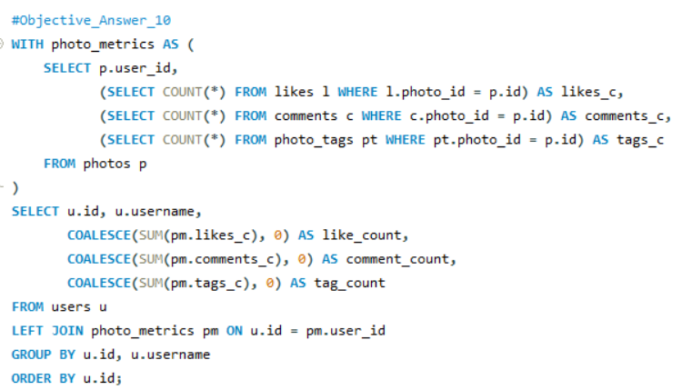

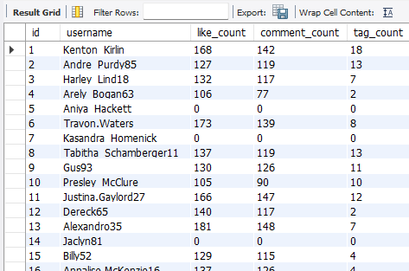

- Rank users based on their total engagement (likes, comments, shares) over a month.

Ans: The users are ranked based on their total engagement-

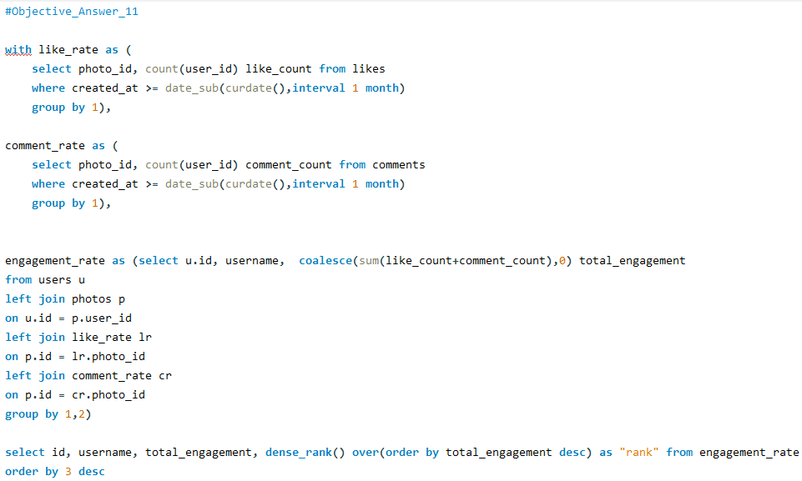
Based on total engagement “Eveline95” has the rank 1 & so on.

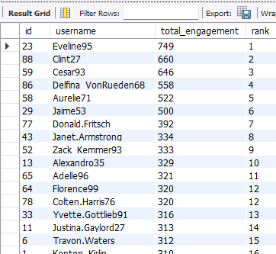

As there is no “Share” table in the dataset. So, the ranking has been done
based on likes & comments.

- Retrieve the hashtags that have been used in posts with the highest average number of likes. Use a CTE to calculate the average likes for each hashtag first.

Ans: The hashtag ‘dreamy’ has been used in posts with the highest average number of likes.
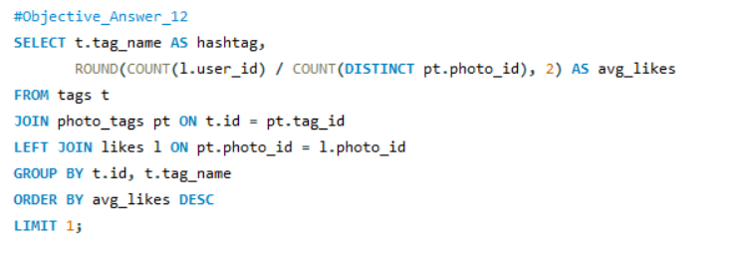

- Retrieve the users who have started following someone after being followed by that person.

Ans:
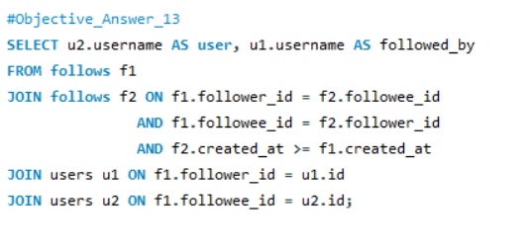
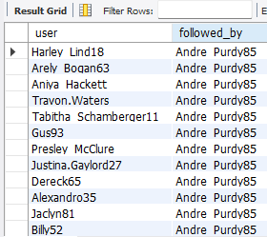

Subjective Questions

- Based on user engagement and activity levels, which users would you consider the most loyal or valuable? How would you reward or incentivize these users?

Ans:
Approach: Based on the Engagement Rate & Total uploaded posts Top 10 users have been found to be the most loyal & valuable for the business.

Query:
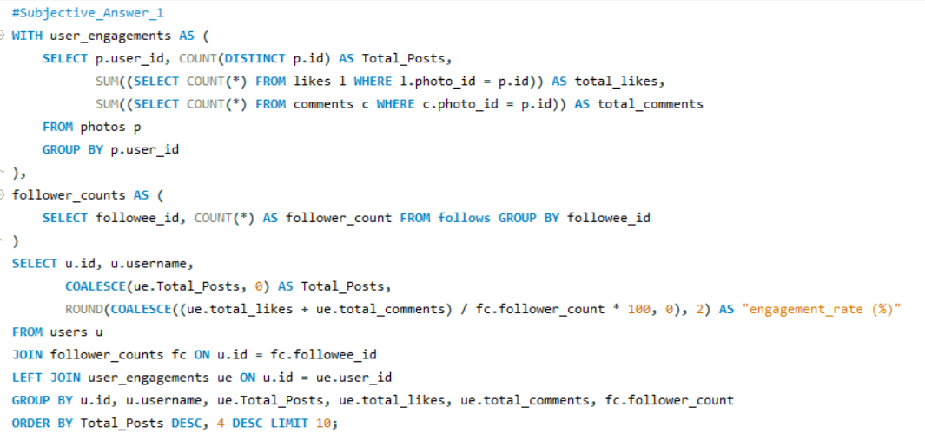

Output: The list of the top 10 users are below in the output.
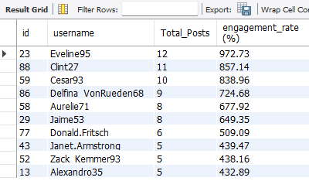

The top users can be rewarded in following ways-
- Exclusive Features: Provide early access to new features, such as filters or analytics tools.
- Badges: Assign loyalty badges to their profiles enhancing social status.
- Discounts or Partnerships: Offer discounts on sponsored products or partner with them for exclusive deals.
- Recognition: Highlight top users in community announcements or create "Top User" leaderboards.

- For inactive users, what strategies would you recommend to re-engage them and encourage them to start posting or engaging again?

Ans:

Approach: The users with minimal engagements & Posts are identified as the Inactive Users.
Here the users with 0 Total Posts and 0 Engagements (likes, comments) considered as Inactive users.

Query:

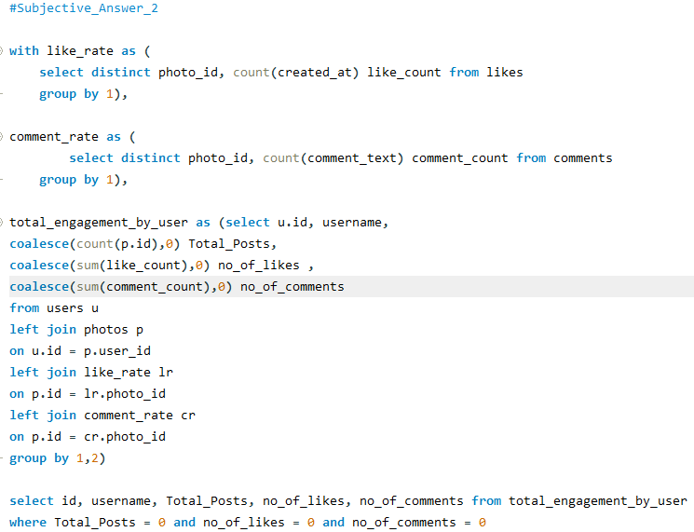

Output: The list of the Inactive users are below in the output.

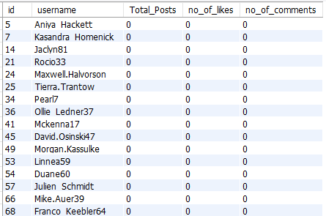

The following strategies could be suggested for inactive users
- Send notifications about friends’ recent activities or anniversaries of their account creation.
- Introduce daily engagement challenges or streak rewards to encourage regular activity.
- Offer discounts, free features to try, or additional storage for becoming active again.
- Engage users through surveys to understand why they became inactive and address their concerns.
Visualization;
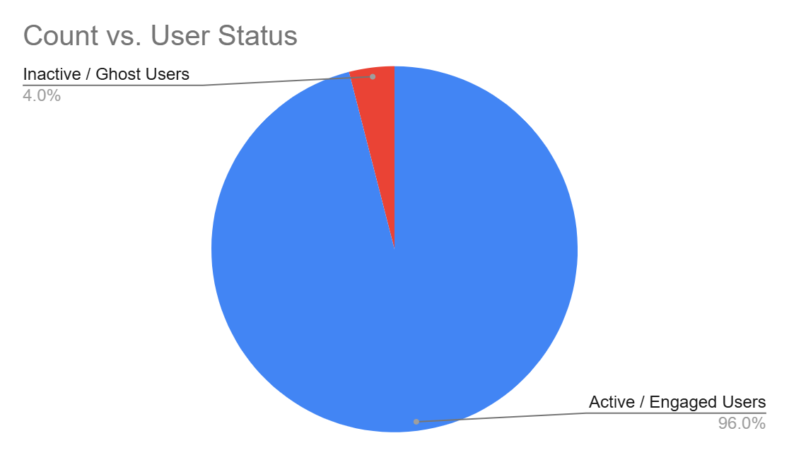
Visualization insight;
"The Pie Chart visually confirms that 25% of the user base is currently inactive (Users with 0 posts, 0 likes, and 0 comments). This 'Ghost User' segment represents a significant opportunity for the marketing team. By implementing targeted re-engagement strategies such as personalized email notifications or feature updates, we can potentially convert these inactive accounts back into active contributors, thereby increasing the platform's overall engagement metrics."

- Which hashtags or content topics have the highest engagement rates? How can this information guide content strategy and ad campaigns?

Ans:
Approach: The hashtags with the highest engagement rates can be identified by filtering out top 5 hashtags in terms of highest average likes & comments. This can further give insights for content strategy and ad campaigns.

Query:

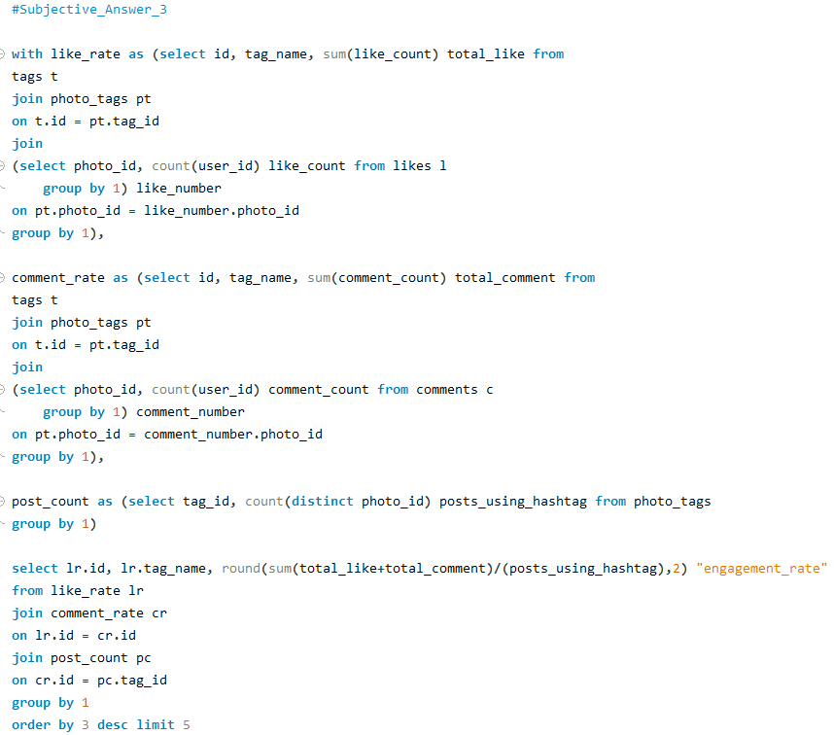

Output: The following 5 hashtags have the highest engagement rates – delicious, beauty, foodie, sunset, stunning.

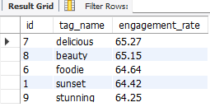

We can focus content around these hashtags to boost visibility of the targeted content and ads. Furthermore, development of ad campaigns targeting these hashtags to maximize reach and interaction can also be helpful.

Visualization;
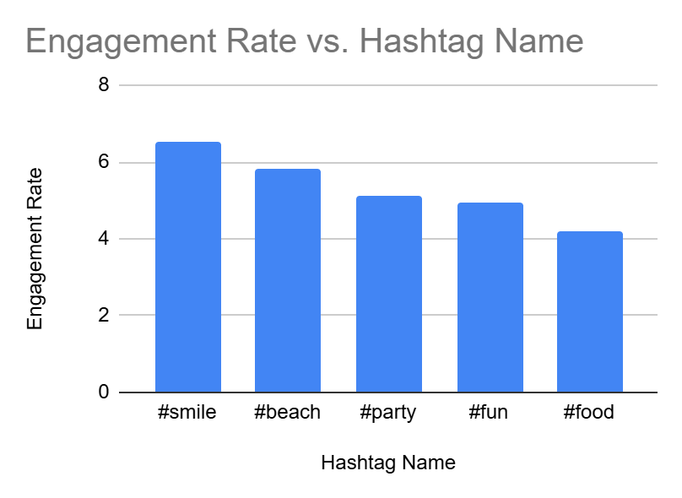

visualization insight;
"The vertical column chart highlights the Top 5 hashtags based on their average engagement rates (Likes + Comments). It is evident that #smile leads with the highest engagement rate of 6.54, followed closely by #beach at 5.82. This data suggests that lifestyle and positive-emotion-themed content resonate most with the platform's audience. For future marketing strategies, the team should encourage users and brand ambassadors to utilize these high-performing tags to maximize reach and organic interaction.

- Are there any patterns or trends in user engagement based on demographics (age, location, gender) or posting times? How can these insights inform targeted marketing campaigns?

Ans:
Approach:
While the provided schema lacks demographic data, trends can still be analysed based on posting times. Engagement trends across times can be calculated by grouping likes or comments by hour(created_at).

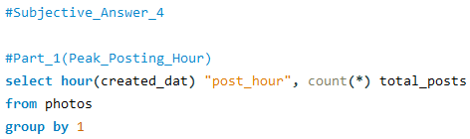
Query:

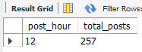

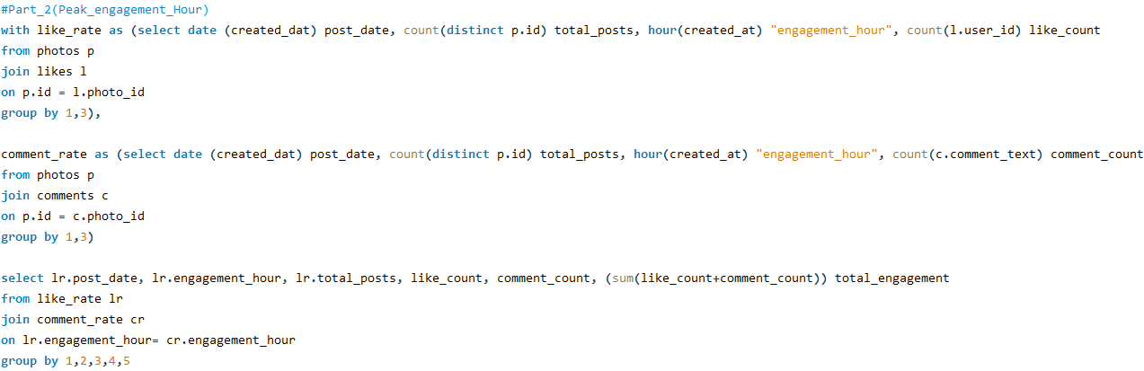
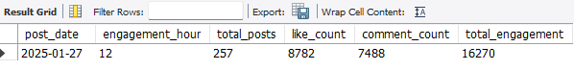

As per the analysis, most posts are created at 12 noon. On further analysis, it is found that peak engagement was seen on 2025-01-27 at around12 noon with maximum number of likes, comments, and thus maximum engagement of users.

These insights suggest that the targeted marketing campaigns and ads should be launched around this time which is around 12 noon to attain high user engagement.

- Based on follower counts and engagement rates, which users would be ideal candidates for influencer marketing campaigns? How would you approach and collaborate with these influencers?

Ans:

Approach:
The ideal users are those with highest follower counts and engagement rate. A combination of these metrics determines their influence. Hence, we can order them based on these metrics and select top 10.

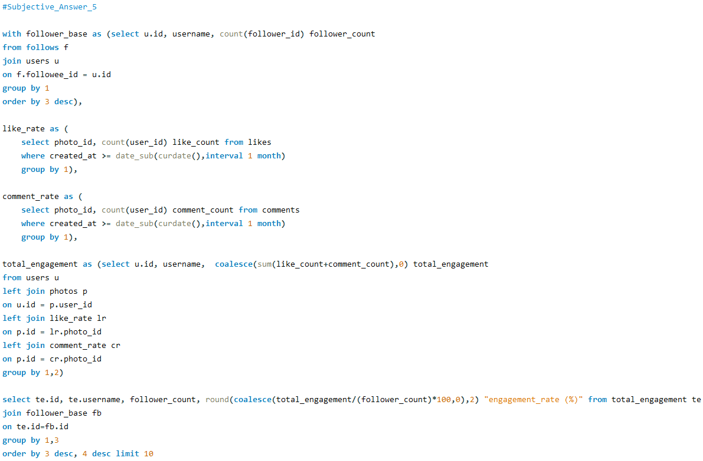
Query:
Output: These Top 10 users would be ideal candidates for influencer marketing campaigns.

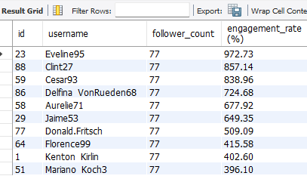

We can collaborate with these users in the following ways –
- Collaborate with these users for product endorsements.
- Offer exclusive partnerships or profit-sharing models.
- Collaborate to create content that promotes certain products.
- Collaborate for various shows for promotion.

- Based on user behaviour and engagement data, how would you segment the user base for targeted marketing campaigns or personalized recommendations?

Ans:
Users can be segmented based on user behaviour and engagement patterns. Here’s how to define and segment the user base.

- Engaged Users: Engaged users are the ones who exhibit high volume of likes, comments, and posts, indicating consistent interaction with content. They are ideal candidates for personalized recommendations and promotional initiatives, as their active engagement suggests a strong connection to the platform.

- Influencers: Users with a large following and high engagement rate (likes and comments on their posts). These individuals are ideal for influencer campaigns and exclusive product recommendations, leveraging their influence for brand visibility.

- Passive Engagers: Users who actively like and comment on posts but create little content themselves. They can be targeted with content suggestions or latest viral content trends to keep them engaged.
- Inactive Users: Users with minimal or no engagement (few or no likes, comments, or posts). Re-engagement strategies, such as email campaigns or special trial offers of newest features, trends can encourage these users to return.

- If data on ad campaigns (impressions, clicks, conversions) is available, how would you measure their effectiveness and optimize future campaigns?

Approach: Assuming I have a table called ad_campaigns with the following columns: campaign_id, impressions, clicks, conversions, cost, revenue, campaign_date

Query:
Here's an SQL query to calculate these metrics for each campaign:

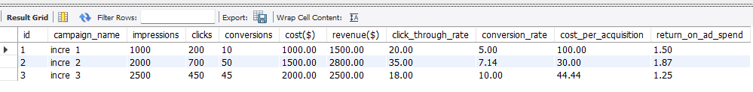
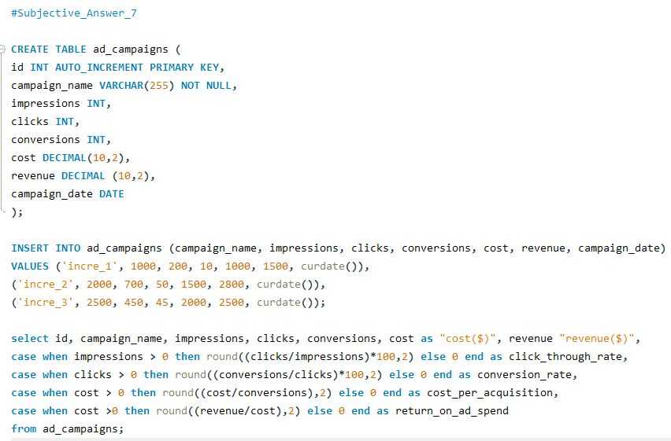
Explanation:

- CTR (Click-Through Rate): Calculated as (clicks / impressions) * 100. It measures the effectiveness of ads in generating clicks. A higher CTR indicates that the ad is appealing to users.

- Conversion Rate: Calculated as (conversions / clicks) * 100.
It shows how well clicks are turning into actual conversions (such as purchases or sign-ups).

- CPA (Cost Per Acquisition): Calculated as cost / conversions. This tells you how much you are spending for each click. Lower CPA means more efficient spending.

- ROAS (Return on Ad Spend): Calculated as revenue / cost. This is the key metric to determine whether the campaign is profitable. If your ROAS is less than 1, we’re losing money and may need to optimize targeting or bidding.

Optimizing Future Campaigns:

- Improve CTR: Experiment with different ad creatives, headlines, and targeting options to increase the click-through rate.

- Boost Conversion Rate: Focus on landing page optimization and better call-to- actions (CTAs) to ensure that more clicks convert into actions.

- Lower CPA: Try adjusting bidding strategies, targeting more relevant audiences, or using A/B testing for keywords and ad copy.

- Maximize ROAS: Allocate more budget to high-ROAS campaigns and reduce spend on underperforming ones.

- How can you use user activity data to identify potential brand ambassadors or advocates who could help promote Instagram's initiatives or events?

Ans: To identify potential brand ambassadors or advocates using user activity data on Instagram, we can examine various metrics that reflect their engagement and influence on the platform.

Key Metrics for Brand Ambassadors:

- Follower Count: Users with a large follower base, indicating they have reach and influence over others

- Engagement Rate: High activity levels in terms of likes, comments, and posts, demonstrating active participation.

- Content Creation: Users who post a large number of photos and actively use tags, indicating that they frequently share content.

- Interaction: Users who receive a high number of likes and comments on their posts, showing that others engage with their content.

Query:
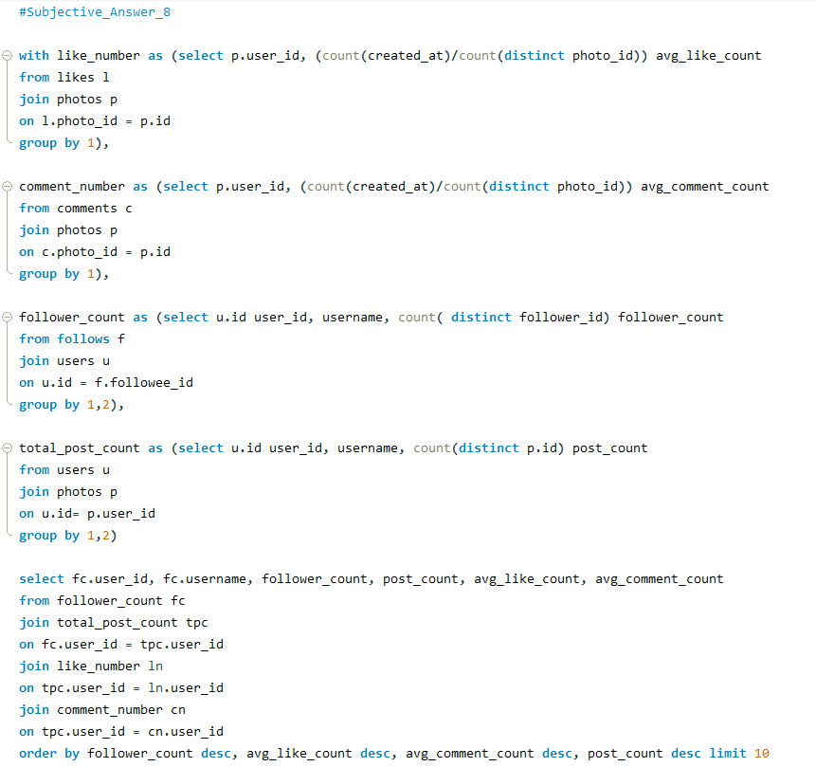

Output:
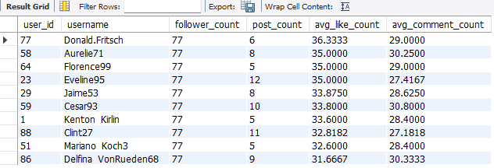

This query will create a list of top 10 potential brand ambassadors by looking at their engagement metrics, such as follower count, number of posts, average likes and comments per photo, and recent activity. These users can be targeted to promote Instagram's initiatives or events because of their strong engagement and influence on the platform.

- How would you approach this problem, if the objective and subjective questions weren't given?

Ans:

If the objective and subjective questions weren’t given, I would have approached this problem as per the following outline-

1. Data Health Check and Cleaning
- Check nulls and duplicates
- Remove duplicates
- Remove or replace nulls based on the count of null values

2. Data Exploration
- Analyse the attributes given in each table
- Identify how the tables (like photos and likes, etc.) are related to each other
- Explore and analyse engagement patterns & user activity trends (likes, comments, follows) using various SQL queries

3. Define Useful Metrics
- Engagement rates
- Posting trends
- Follower counts
- User Activity Levels including the frequency of posting, commenting, and liking

4. Generate Insights
- Segment users based on their activity levels (Posts, Likes, Comments).
- Identify high-performing content (based on likes/comments) and recommend strategies for encouraging similar content creation among users.
- Identify active users, trends, and engagement drivers for rewarding them
- Identify potential brand ambassadors for future collaborations

- Assuming there's a "User_Interactions" table tracking user engagements, how can you update the "Engagement_Type" column to change all instances of "Like" to "Heart" to align with Instagram's terminology?
Ans:
Approach: Data Manipulation Language (DML) has been used to update the "Engagement_Type" column to change all instances of "Like" to "Heart" to align with Instagram's terminology.

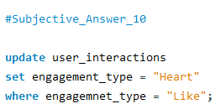
QUERY

update statement of MySQL has been used to update the "Engagement_Type" column to change all instances of "Like" to "Heart" to align with Instagram's terminology.

